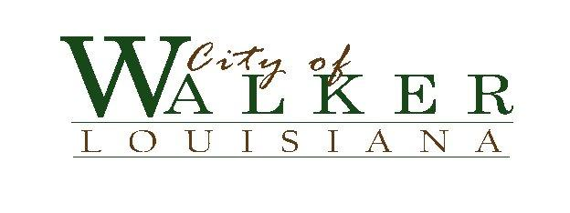
ALCOHOL BEVERAGE CONTROL BOARD
ABC BOARD MEETING MINUTES
April 7, 2014 at 9:00 a.m.

The scheduled meeting of the ABC Board for the City of Walker was held at the City Hall on January 22, 2014 at 9:00 a.m. Present were Chairman, Fred Raiford, Board members, William Aydell, Denver Populis, Myra Streeter and Belinda McCullough. Ryan Dutsch and Brenda Tedder were absent.
The meeting was called to order by Mr. Raiford and roll was called by Mrs. Frey. Mr. Raiford began the meeting.

Mr. Aydell made a motion to approve the minutes from January 22, 2014, seconded by Mr. Populis.

Yeas: Aydell, Populis, Streeter, McCullough
Nays: None
Absent: Dutsch and Tedder

Mr. Fred brought up the proposed revisions to the Alcohol Ordinance and explained the importance of the revisions. Mrs. Streeter made a motion to approve the revisions, seconded by Mr. Aydell.

Yeas: Aydell, Populis, Streeter, McCullough
Nays: None
Absent: Dutsch and Tedder

There being no further business to discuss, Mrs. Streeter made a motion to adjourn, seconded by Mr. Populis.

Yeas: Aydell, Populis, Streeter, McCullough
Nays: None
Absent: Dutsch and Tedder

RESPECTFULLY SUBMITTED:

___________________________
Fred Raiford, Chairman, ABC Board

ATTEST:

_______________________
Lisa Frey, ABC Secretary

