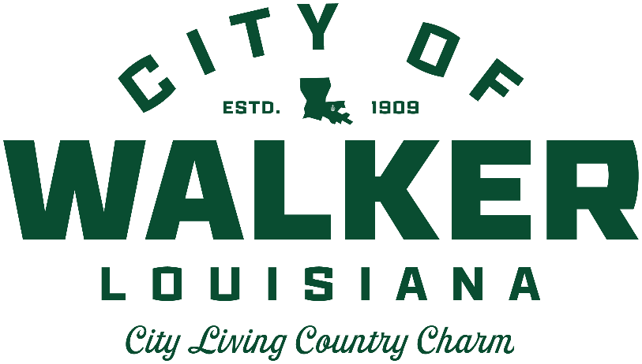
MAYOR PRO TEM
Scarlett Milton Major

COUNCIL
David Clark
Eric Cook
Gary Griffin
Scarlett Milton Major
Richard Wales

MAYOR
Jimmy Watson

CITY ATTORNEY
Bobby King

CHIEF OF OPERATIONS
Jamie Etheridge

CITY CLERK
Tammy Payton

CITY COUNCIL MEETING AGENDA

August 9, 2021 6:00 PM

1. CALL MEETING TO ORDER / ROLL CALL MAYOR
2. MINUTES / COMMENTS – July 12, 2021 Council Meeting MAYOR
3. FINANCE REPORT COTTON
4 INTRODUCTION/AMEND CH. 4/ANIMALS AND FOWL:
ANIMAL FIGHTING PARAPHERNALIA.
5. INTRODUCTION/AMEND CH. 4/ANIMALS AND FOWL:
OBSTRUCTION OF JUSTICE
6. INTRODUCTION/BUDGET AMENDMENT 4/SPECIAL NEEDS PLAYGROUND
7. INTRODUCTION/BUDGET AMENDMENT 5/IMPROVEMENTS FOR
PARKS AND RECREATION
8. POLICE DEPARTMENT/OFFICER STATUS CHANGES ADDISON
9. ADDITIONAL COMMENTS MAYOR
10. ADJOURN MAYOR

**Pursuant to Louisiana Revised Statute 42:17, the Mayor and City Council of the City of Walker may adjourn into executive session to discuss pending litigation, security or personnel issues or any other matters provided for by the legislature.
**Pursuant to Louisiana Revised Statute 42:14, the public will be allowed to make comments before each item on the agenda requiring a vote of the City Council.

